**eTraining Portal (Philippines)  
HR Requests**

1. Email notification of Training Schedule to the participants after batching.
2. Email notification to the managers after 90 Days that they need to complete the training effectiveness review.
3. Change Normal to In-House and Adhoc/Public Run to External  
   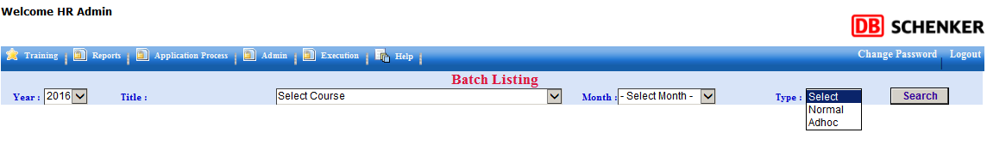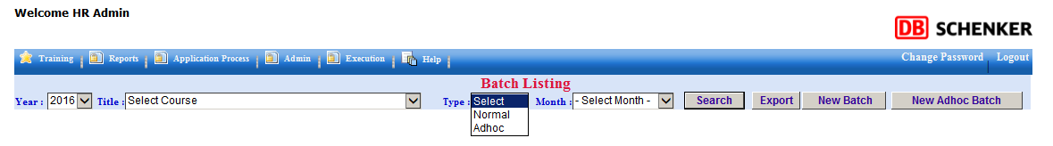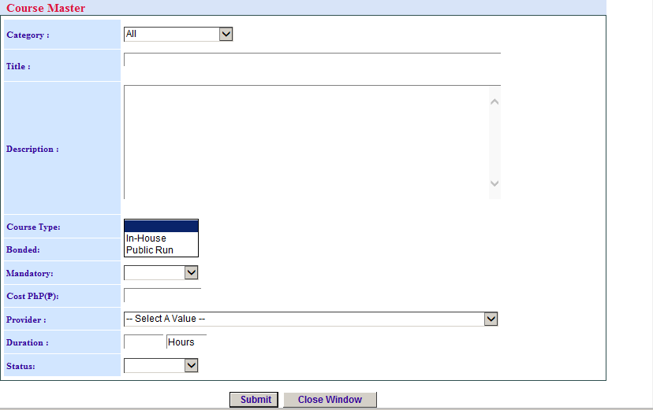
4. Add Export User and Export Provider  
   